Set Virtual COM for STM32 Scanners
Purpose
The document is aimed to illustrate the setup of STM32 scanner with Virtual COM interface.

Scope
This document is applicable to SG100, SG300/BT, SG600/BT, SG700/BT, LG100, LG300/BT, LG610/BT, LG700/BT, V-1010/BT, V-1020.BT, V-1030/BT, V-1040/BT, SD100, SD120, SD300, SD320, SD500, and SD700.

Requirements
- USB cable connecting to the PC
- Virtual COM Driver

Procedure
Install the Virtual COM driver first
-VCP_V1.3.1_Setup.exe is for 32bit O.S
-VCP_V1.3.1_Setup_x64.exe is for 64bit O.S
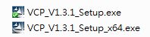
After the V.COM driver installation:
-Scan the following labels sequentially to set scanner interface and required parameters.
Start Configuration

Virtual COM


End Configuration

Save Parameters


-RS232 default parameters are as follows:
●Baud Rate: 9600
●Data Bits: 8
●Stop Bit: 1
●Parity: None
●RTS/CTS: Disable
●ACK/NAK: Disable
●XON/XOFF: Disable

-Connect the USB cable to PC first, after a while, Windows will find the device and automatically identify and configuring the V.COM device.
-The wizard will copy Virtual COM driver automatically.
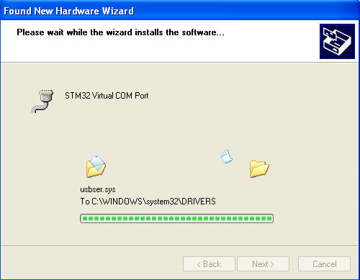

-The message ‘The new hardware is installed and ready to use…’ will show up at the tray bar.

